**Webtech Lab FAT**

**Binayak Bishnu**

**20BIT0155**

**Question**

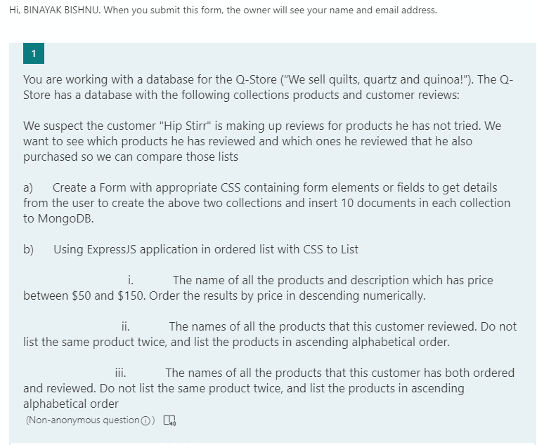

**Code**

HTML

<!DOCTYPE html>

<html lang="en">

<head>

    <meta charset="UTF-8">

    <meta http-equiv="X-UA-Compatible" content="IE=edge">

    <meta name="viewport" content="width=device-width, initial-scale=1.0">

    <title>20BIT0155</title>

</head>

<body>

    <form id="myForm" name="myForm" action="/submitted" method="POST">

        <div>

            <label for="customerid">Customer ID:</label>

            <input type="text" name="customerid" id="customerid" />

        </div>

        <div>

            <label for="customername">Customer:</label>

            <input type="text" name="customername" id="customername" />

        </div>

        <div>

            <label for="customeraddr">Customer Address:</label>

            <textarea name="customeraddr" id="customeraddr"></textarea>

        </div>

        <div>

            <label for="customeremail">Customer Email ID:</label>

            <input type="email" name="customeremail" id="customeremail" />

        </div>

        <br /><br />

        <div>

            <label for="prodid">Product ID:</label>

            <input type="text" name="prodid" id="prodid" />

        </div>

        <div>

            <label for="prodname">Product:</label>

            <input type="text" name="prodname" id="prodname" />

        </div>

        <div>

            <label for="desp">Description:</label>

            <textarea name="desp" id="desp"></textarea>

        </div>

        <div>

            <label for="image">Image:</label>

            <input type="file" id="image" name="image" />

        </div>

        <div>

            <label for="price">Price:</label>

            <input type="number" name="price" id="price" />

        </div>

        <br /><br />

        <div>

            <label for="reviewid">Review ID:</label>

            <input type="text" name="reviewid" id="reviewid" />

        </div>

        <div>

            <label for="review">Review:</label>

            <textarea name="review" id="review"></textarea>

        </div>

        <input type="submit" name="submit" value="Submit" id="submit" />

        <br /><br />

    </form>

    <div>

        <h3>Queries</h3>

        <form action="/part_i" method="GET">

            <input type="submit" name="part_i" value="Part i" />

        </form>

        <form action="/part_ii" method="GET">

            <input type="submit" name="part_ii" value="Part ii" />

        </form>

        <form action="/part_iii" method="GET">

            <input type="submit" name="part_iii" value="Part iii" />

        </form>

    </div>

</body>

</html>

Server

const express = require('express');

const bodyParser = require('body-parser');

const path = require('path');

const MongoClient = require('mongodb').MongoClient;

const app = express()

const u = bodyParser.urlencoded({ extended: false })

app.use(express.static(path.join(__dirname, 'html')))

app.use(express.static(path.join(__dirname, 'css')))

app.use(express.static(path.join(__dirname, 'assets')))

app.get('/20BIT0155.html', (req, res) => {

    res.sendFile(path.join(__dirname, '20BIT0155.html'))

})

app.post('/submitted', u, function (req, res) {

    var product = {

        product_id: req.body.prodid,

        name: req.body.prodname,

        description: req.body.desp,

        image: req.body.image,

        price: req.body.price,

    }

    var customer = {

        customer_id: req.body.customerid,

        name: req.body.customername,

        address: req.body.customeraddr,

        email: req.body.customeremail,

    }

    var review = {

        review_id: req.body.reviewid,

        customer_id: req.body.customerid,

        product_id: req.body.prodid,

        review: req.body.review,

    }

    MongoClient.connect('mongodb://localhost:27017/', function (err, db) {

        if (err)

            throw err;

        else

            console.log("mongo connected!")

        var dbo = db.db("QStore");

        dbo.collection('products').insertOne(product);

        dbo.collection('customers').insertOne(customer);

        dbo.collection('reviews').insertOne(review);

    })

    res.send("<h1>Submitted!!!</h1>")

})

app.get('/part_i', u, function (req, res) {

    MongoClient.connect('mongodb://localhost:27017/', function (err, db) {

        if (err) throw err;

        var dbo = db.db("QStore");

        var query1 = { price: {$gte:25,$lte:150} };

        dbo.collection("products").find(query1).toArray(function (err, result) {

            if (err) throw err;

            console.log(result);

            res.send(result);

            db.close();

        });

    });

})

app.get('/part_ii', u, function (req, res) {

    MongoClient.connect('mongodb://localhost:27017/', function (err, db) {

        if (err) throw err;

        var dbo = db.db("QStore");

        var query2 = { customer_id: '1234' };

        dbo.collection("products").find(query2).toArray(function (err, result) {

            if (err) throw err;

            console.log(result);

            res.send(result);

            db.close();

        });

    });

})

app.get('/part_iii', u, function (req, res) {

    MongoClient.connect('mongodb://localhost:27017/', function (err, db) {

        if (err) throw err;

        var dbo = db.db("QStore");

        var query3 = { customer_id: '1234' };

        dbo.collection("reviews").find(query3).toArray(function (err, result) {

            if (err) throw err;

            console.log(result);

            res.send(result);

            db.close();

        });

        dbo.collection("products").find(query3).toArray(function (err, result) {

            if (err) throw err;

            console.log(result);

            res.send(result);

            db.close();

        });

    });

})

app.listen(1234, () => {

    console.log('Running...')

})

**Outputs**

Server running

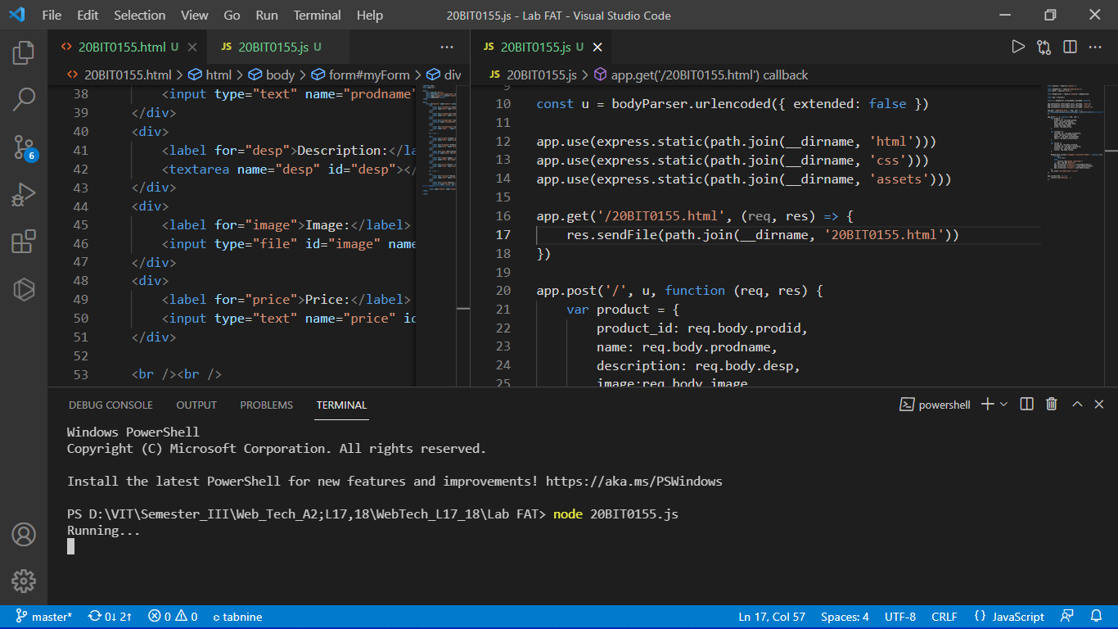

Form

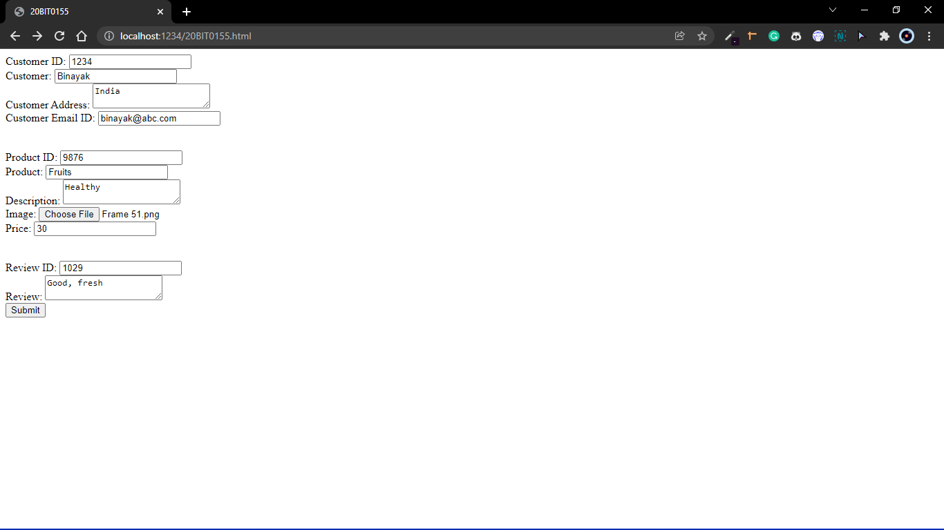

Confirmation of submission

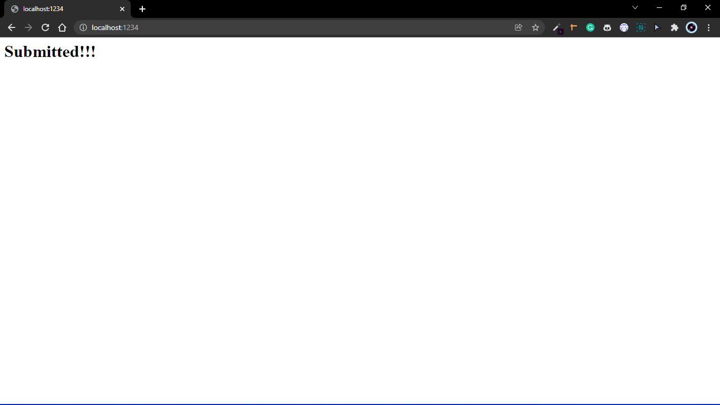

Database created by nodejs

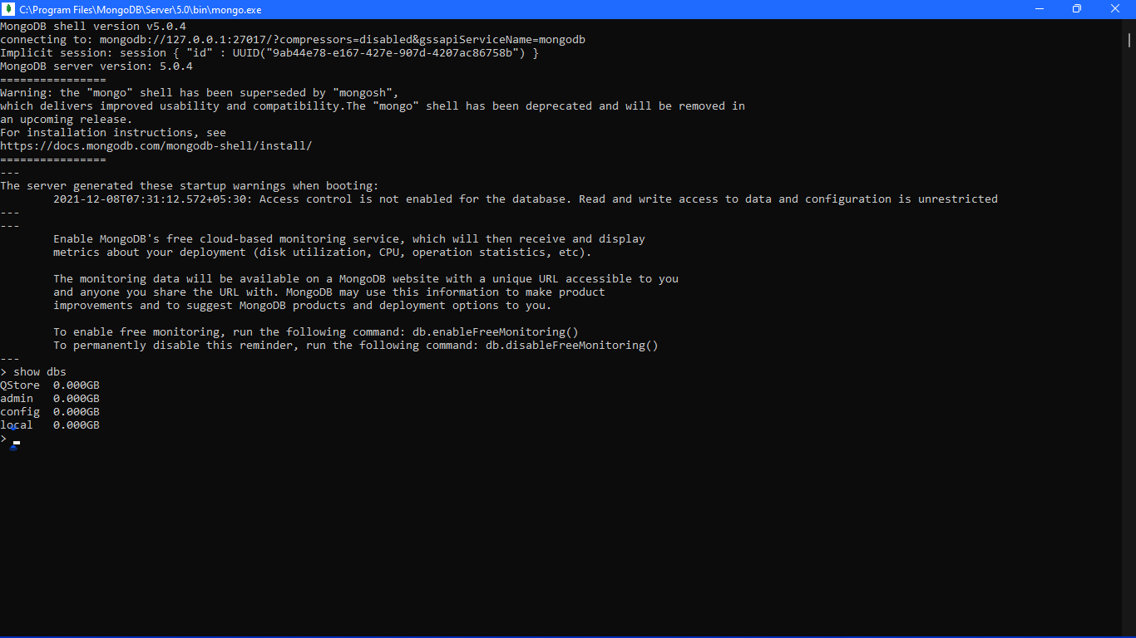

Three collections also made

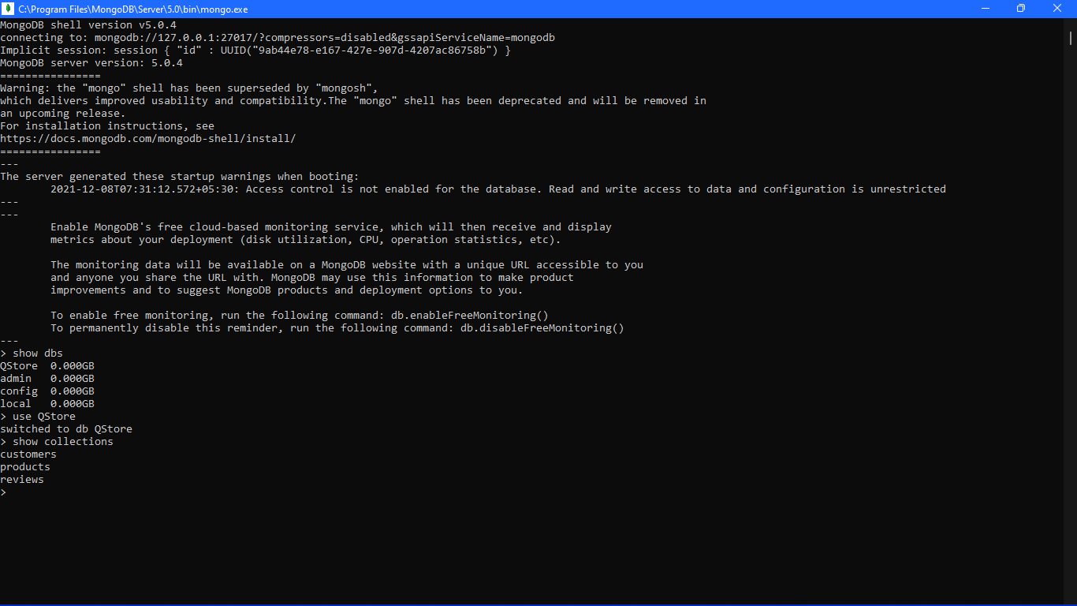

First set of data

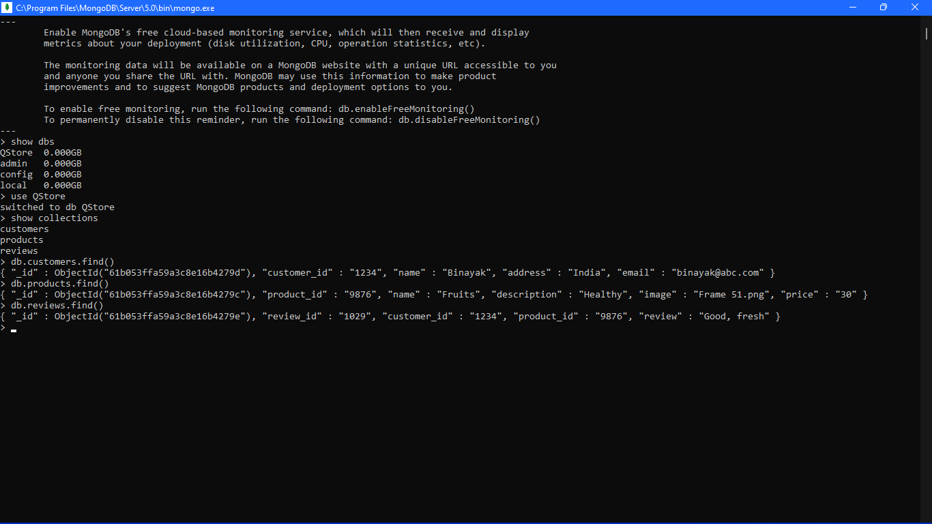

Ten data added by form via nodejs

